Seed and Soil Program 2022
Information Sheet for Households

Welcome to the Seed and Soil Program!
2022 is the Year of the Garden in Ottawa! The Just Food Seed and Soil Program provides you with the seed, soil, and information to grow vegetable plants in your garden, yard, or balcony. Your garden can feed your family and friends Good Food!
This program is run in partnership with Greely Sand & Gravel and the City of Ottawa, and amazing volunteers and community partners in your neighbourhood.
You can receive a minimum of 6 vegetable seed varieties. The seed is ready for organic growing, which means that they are free from any pesticides or other chemicals. See the Seed Instructions on the next page for information on how to plant and grow your seed.
You can also receive approximately 160 litres of organic top-soil - enough to fill three blue / black recycling bins. This is about $40 worth of soil!
This soil is high quality, full of nutrients, and chemical free. It can be used for your vegetable seed or other plants.

Gardening Resources…
Just Food Garden Guide:
Do you want a detailed guide on growing from seed, planning a garden layout, composting, harvesting, and more?
Read the Just Food Garden Guide (available in English, French, Arabic, Mandarin, Spanish): justfood.ca/gardenguide
Gardening Workshops:
Just Food is always hosting new virtual and in-person workshops on how to garden in Ottawa: justfood.ca/gardening-workshops
Vermicomposting:
Looking for ways to use your household food scraps to give your plants more nutrients? Vermicomposting uses worms to break down food scraps and turn it into a rich, dark soil.
Our friends at The Box of Life have an indoor vermicomposting system that even works in apartments: www.theboxoflife.com

Coming soon: Yardshare (for neighbours to match up yards with gardeners) and GoodFoodLink.ca (a website to link you to everything about food and farming in this region.)

Got Questions?
If you have questions about how to garden, you can also ask a local Master Gardener at: mgoc_helpline@yahoo.ca
If you want to get involved with Just Food, please join the newsletter and volunteer opportunities found at https://justfood.nationbuilder.com/newsletter_signup
Kids can also ask questions about gardening all season long to Farmer Chadwick at Just Food by emailing: farmschool@justfood.ca
You can also ask the team members running your Distribution Event any questions you may have. Happy Gardening!
- Choose a spot with sun:
  - Full sun = 6 hours/day or more
  - Partial sun = 3-6 hours/day
- Prepare your growing space:
  - Use a shovel to loosen up the soil in a garden bed or pot
  - Take out the undesired plants (grass, etc.) and add in your new soil on top of the newly prepared area
- Plant your seed in the soil:
  - Poke a hole in the soil at the proper seed depth
  - Water the soil until it’s soaked into the soil
  - Put the seed into the hole and cover with a bit of soil
  - Water the soil again (but not too much)
- Maintenance tips:
  - Water at the base of the plant and keep soil moist, not soaking
  - If you can, put mesh or netting over seed for squirrel protection
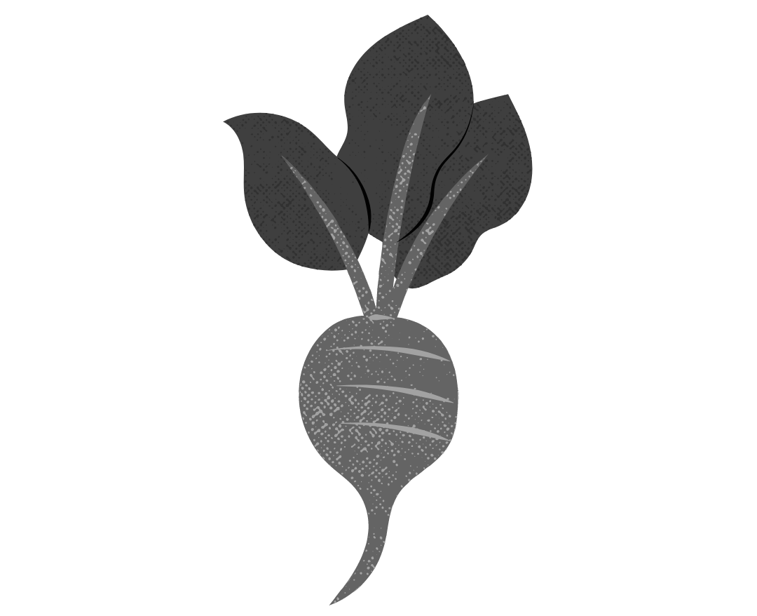
Check the markings on your seed packet and find it on the table below. This will tell you what type of seed you have and how to grow it!
Color / Packet | Image | Plant | Planting Date | Seed Depth | Plant Spacing | Days to Maturity | Sun
Baggie - Orange Mark |  | Beets | Late April to Late July | 1⁄2 inch | 2-4 inches | 45-65 days | Full sun
Baggie - Dark Blue Mark | 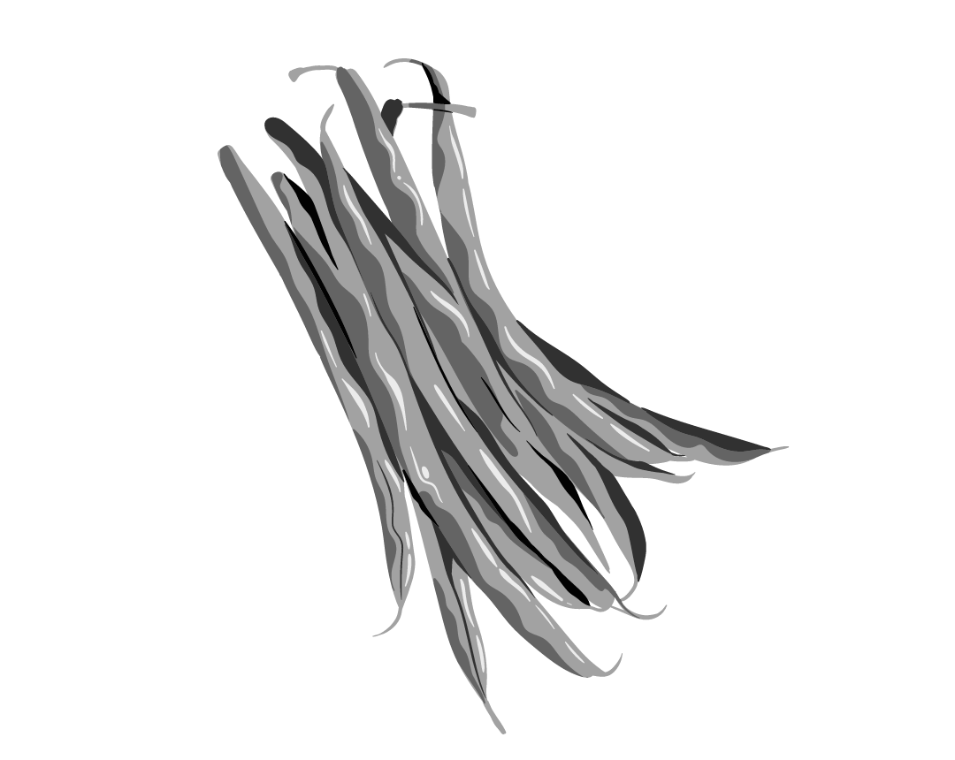 | Beans - Green | Late May to Late July | 1 inch | 3-4 inches | 60 days | Full sun
Baggie - Pink Mark | 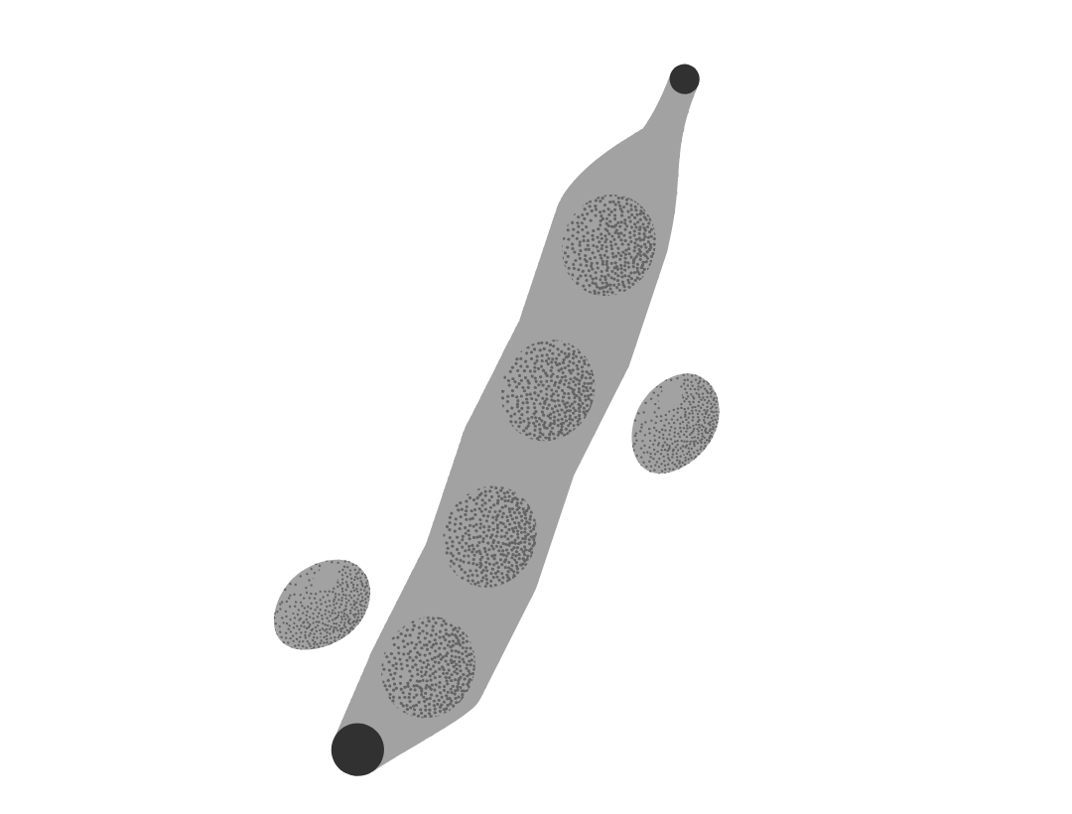 | Beans - Yellow | Late May to Late July | 1 inch | 3-4 inches | 60 days | Full sun
Baggie - Yellow Mark | 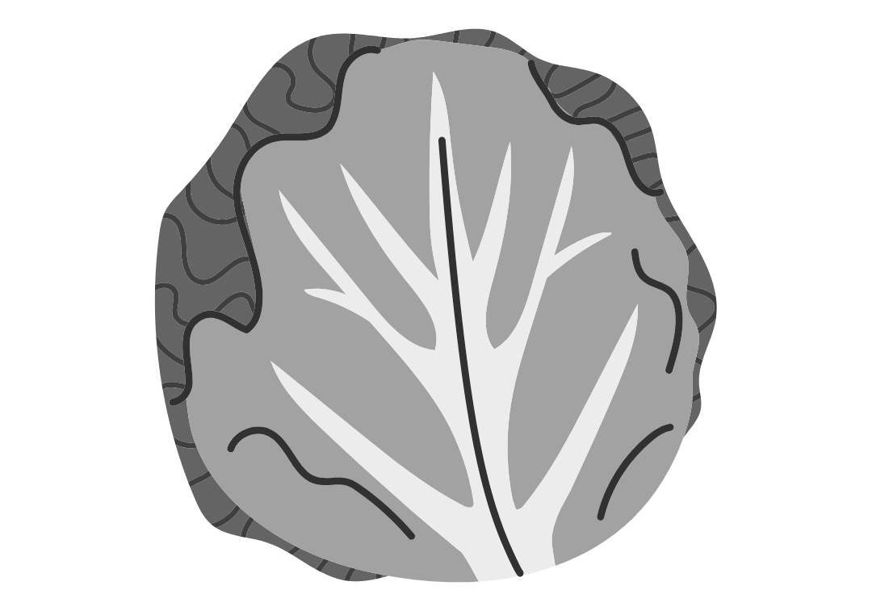 | Cabbage | Late May  *start seeds indoors in late April | 1⁄2 inch | 18 inches | 64 days | Partial sun
Paper Envelope | 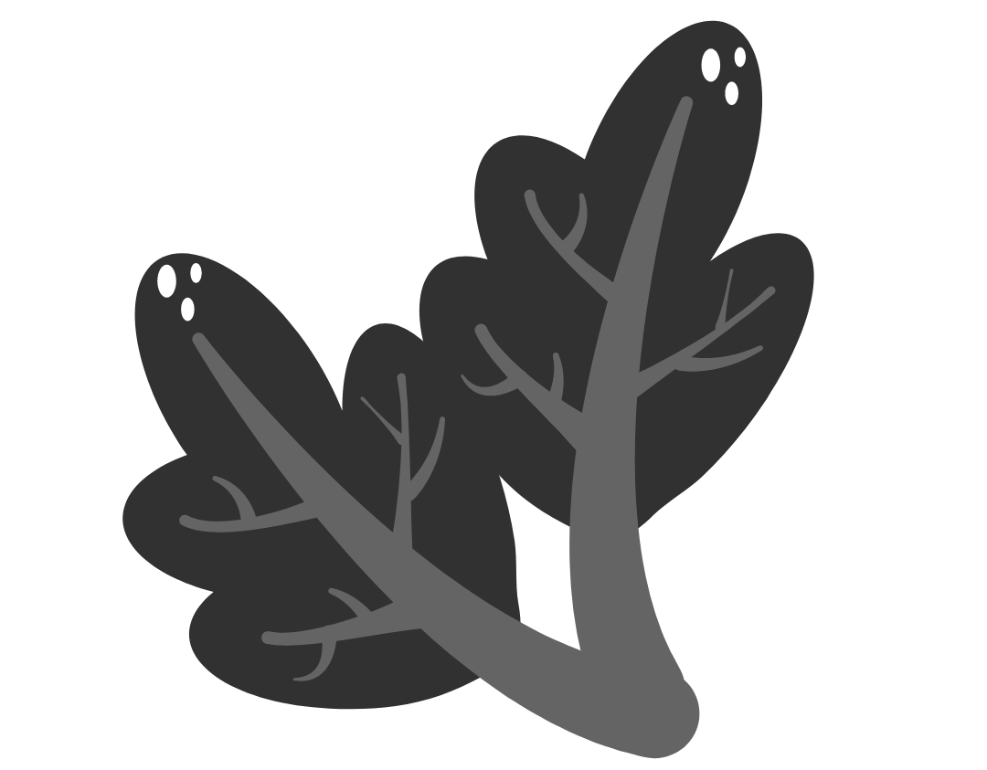 | Chard | Late May | 1⁄2 inch | 2-6 inches | 55-60 days | Full sun or  partial sun
Baggie - Light Blue Mark | 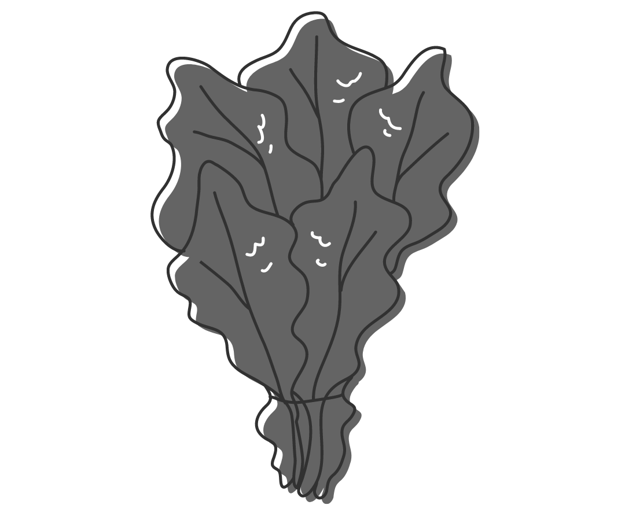 | Kale | Late May | 1⁄2 inch | 3 inches | 55-75 days | Full sun or  partial sun
Paper Envelope | 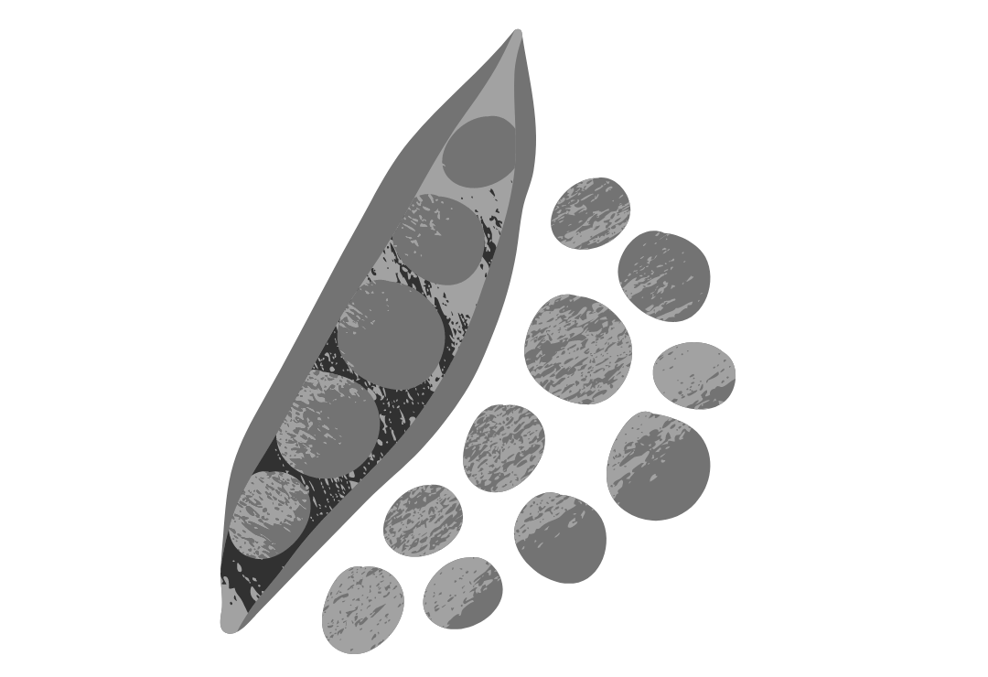 | Peas | Early May to Late July | 1 inch | 3 inches | 21-30 days | Full sun
Baggie - Dark Green Mark | 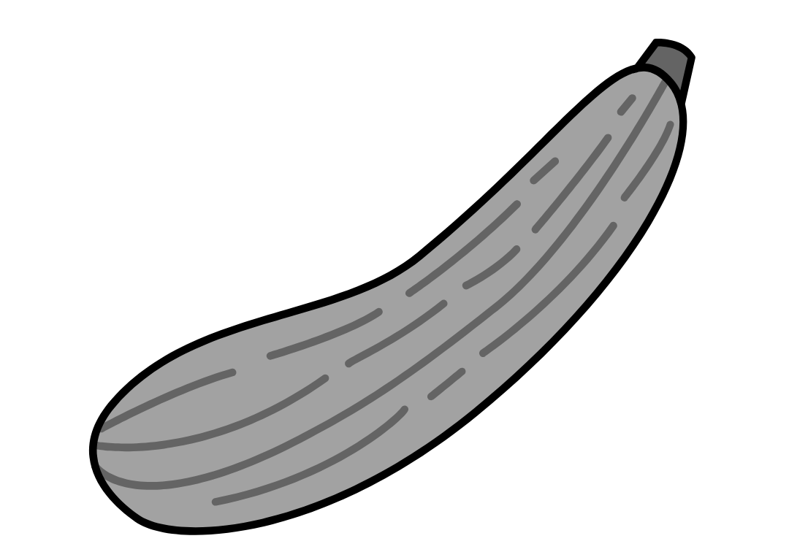 | Squash (Summer Zucchini) | Late May | 1 inch | 10 inches | 50-65 days | Full sun
Baggie - Red Mark | 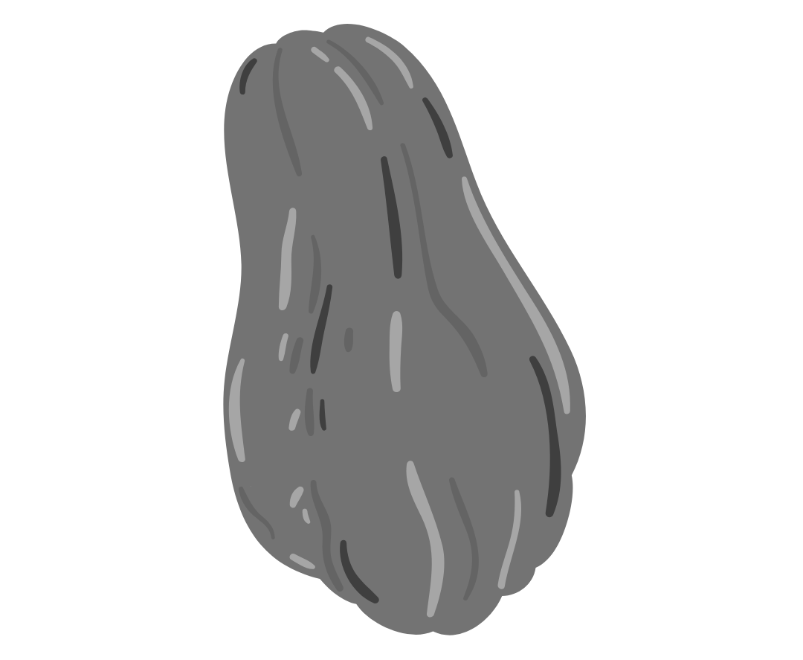 | Squash (Winter Honeynut) | Early June | 1 inch | 36 inches | 50-55 days | Full sun
Baggie - No Mark | 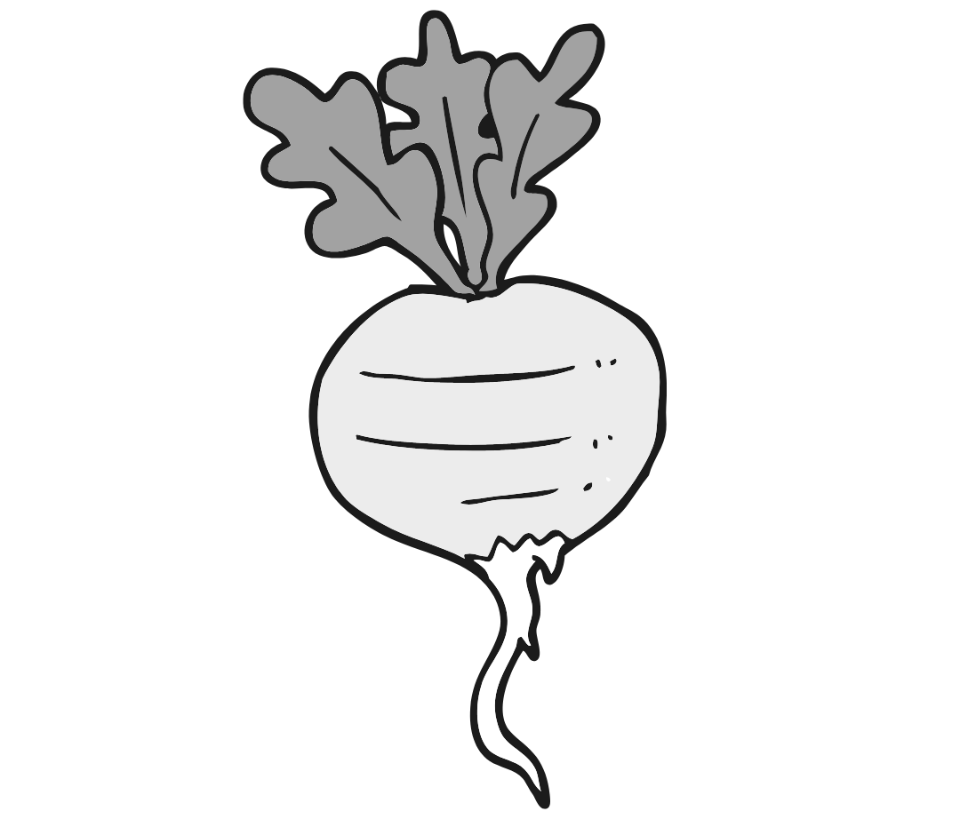 | Turnip | Late April to Early August | 1⁄2 inch | 18-30 inches | 40–50 days | Full sun

